|  |  |  |  |  |  |  |  |  |  |  |  |  |  |  |  |  |  |  |  |  |
| --- | --- | --- | --- | --- | --- | --- | --- | --- | --- | --- | --- | --- | --- | --- | --- | --- | --- | --- | --- | --- |
|  | ADULT SIZES | | | | | | | | | | | KIDS SIZES | | | | | |  |  |  |
|  | 3XS | 2XS | XS | S | M | L | XL | 2XL | 3XL | 4XL | 5XL | 4 | 6 | 8 | 10 | 12 | 14 | ADULT | QTY | TOTAL |
| CLUB BELL POLO |  |  |  |  |  |  |  |  |  |  |  |  |  |  |  |  |  | $40 |  |  |
| CLUB FLEECY HOODIE |  | | |  |  |  |  |  |  |  |  |  |  |  |  |  |  | $60 |  |  |
| CLUB SOFT JACKET |  |  |  |  |  |  |  |  |  |  |  |  |  |  |  |  |  | $70 |  |  |
| CLUB SOFT JACKET (HOODED) |  |  |  |  |  |  |  |  |  |  |  |  |  |  |  |  |  | $75 |  |  |
| SPORTS KIT BAG |  | | | | | | | | | | | | | | |  |  | $35 |  |  |
| BEANIE  (Black only) |  | | | | | | | | | | | | | | |  |  | $25 |  |  |
|  | | | | | | | | | | | | | | | | | | Grand Totals | |  |

**GEOGRAPHE BAY FC MERCHANDISE**

Initial/name embroidery can be arranged at buyers cost, please email at time of purchase.

|  |
| --- |
| NAME: |
| PHONE: |
| EMAIL: |
| PAYMENT DATE: |

Please email order form to [secretary@gbfc.com.au](mailto:secretary@gbfc.com.au) with proof of payment.

Payments by direct deposit to: Geographe Bay Football Club / BSB: 633 000 / Acct No: 1466 7912 1

(USE MERCH & SURNAME AS YOUR BANK REFERENCE)

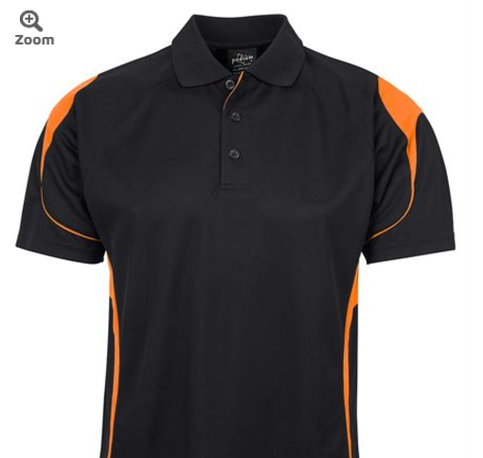 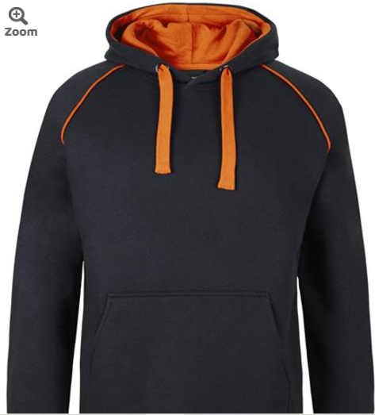 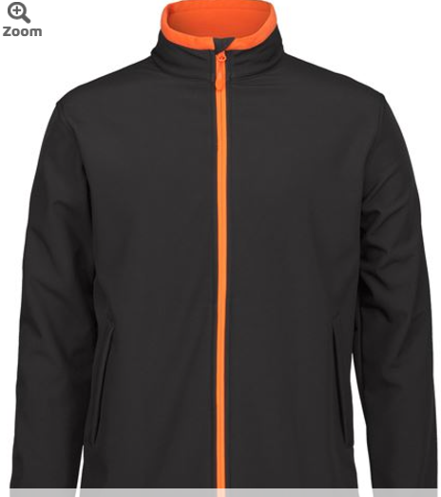 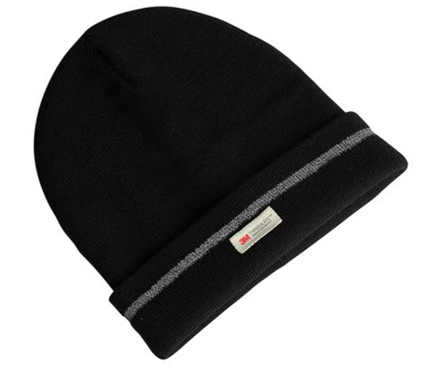 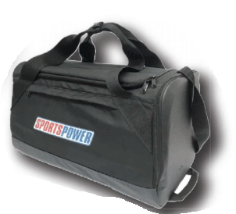 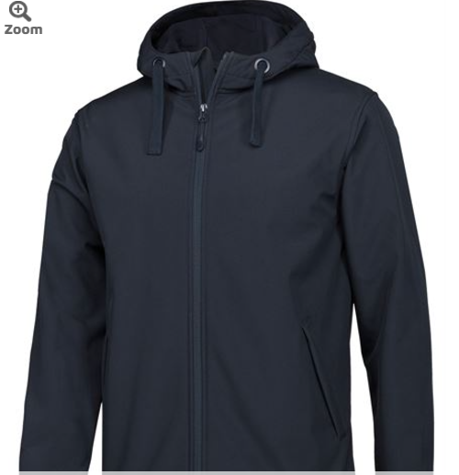

[Podium Bell Polo](https://www.jbswear.com.au/product-detail/-in-product/7BEL) [Club Fleecy Hoodie](https://www.jbswear.com.au/product-detail/-in-product/3CFH) [Club Soft Jacket](https://www.jbswear.com.au/product-detail/-in-product/3WSJ) [Beanie](https://www.jbswear.com.au/product-detail/-in-product/6RNFB) [Kit Bag](https://www.sportspower.com.au/products/sportspower-sports-duffle-bag) [Soft Shell Jacket HOODED](https://www.jbswear.com.au/product-detail/-in-product/3WSH)

